**PROGRAM 4: STUDENT FACULTY DATABASE**

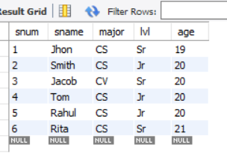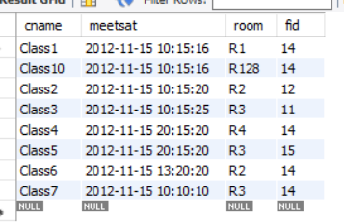

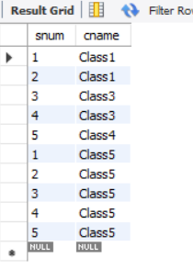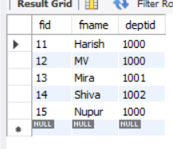

**Queries:**

**1**. Find the names of all Juniors (level = JR) who are enrolled in a class taught by “name”.

select s.sname from STUDENT s, CLASS c, FACULTY f,ENROLLED e

where

s.snum=e.snum and

s.lvl='Jr' and

e.cname=c.cname and

f.fid=c.fid and

f.fname="Harish";

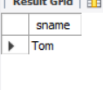

**2.**  Find the names of all classes that either meet in room R128 or have five or more students enrolled.

select c.cname from class c

where c.room = 'R128'or

c.cname in (select e.cname from enrolled e group by e.cname having count(e.snum)>=5);

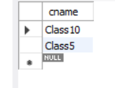

**3**. Find the names of all students who are enrolled in two classes that meet at the same time.

select distinct s.sname from student s

where

s.snum in

(select e1.snum from enrolled e1, enrolled e2,

class c1, class c2

where e1.snum = e2.snum and e1.cname <> e2.cname and e1.cname = c1.cname

and e2.cname = c2.cname and

c1.meetsat = c2.meetsat);

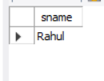

**4.** Find the names of faculty members who teach in every room in which some class is taught.

select distinct f.fname from faculty f

where

not exists

(select room from class

where

room not in (select c.room from class

c where c.fid=f.fid));

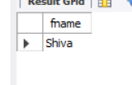

**5.**  Find the names of faculty members for whom the combined enrollment of the courses that they teach is less than five.

select distinct f.fname from faculty f

where 5>

(select COUNT(e.snum) from Class c, enrolled e

where c.cname = e.cname and c.fid = f.fid);

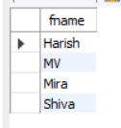

**6.**  Find the names of students who are not enrolled in any class.

select distinct s.sname from student s

where

s.snum not in(select e.snum from enrolled e);

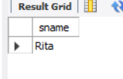

**7.** For each age value that appears in Students, find the level value that appears most

select S.age,S.lvl,count(*) from student S

group by S.age,S.lvl

having S.lvl in (select s1.lvl from Student s1

where s1.age=S.age

group by s1.age,s1.lvl

having count(*)>=all

(Select count(*) from student s2

where s1.age=s2.age group by s2.lvl,s2.age));

